Subject: Data Handling and Visualization
Name: CHEVULA RUPAVATHI
Register Number: 192325077
R. No.: 9
Slot: C
AIM
To analyze energy consumption data using R programming and Tableau by creating histograms, density plots, bubble scatter plots, sector-wise renewable energy usage comparisons, and an interactive dashboard.
Description of attributes:
- Sector: Type of energy consumer.
- Region: Geographical region of consumption.
- Month: Month in which energy consumption was recorded.
- Temperature: Recorded temperature.
- Units_Consumed: Total energy consumed in units.
- Cost: Cost of energy consumption.
- Renewable_Usage: Renewable energy usage value.
- Peak_Hours: Number of peak consumption hours.
PROCESS / PROCEDURE
- Import the required libraries in R.
- Load the energy consumption dataset into R.
- Check the structure and summary of the dataset.
- Create a histogram and density curve for energy consumption.
- Create a bubble scatter plot showing temperature against units consumed, with bubble size representing peak hours.
- Calculate average renewable energy usage for each sector.
- Display the sector-wise renewable usage using a bar chart.
- Import the dataset into Tableau.
- Create a monthly energy consumption trend and a sector-region heatmap.
- Add Month and Sector filters to create an interactive dashboard.
R PROGRAMS
Q1. Histogram and Density Plot of Energy Consumption
Program:
# Set 21: Energy Consumption Analysis

# Import the dataset
energy <- read.csv("energy_consumption.csv")

# Display the dataset
print(energy)

# Histogram of energy consumption
hist(
energy$Units_Consumed,
main = "Histogram of Energy Consumption",
xlab = "Units Consumed",
ylab = "Frequency",
col = "lightblue",
border = "black"
)

# Density plot
plot(
density(energy$Units_Consumed),
main = "Density Plot of Energy Consumption",
xlab = "Units Consumed",
ylab = "Density",
col = "blue",
lwd = 2
)
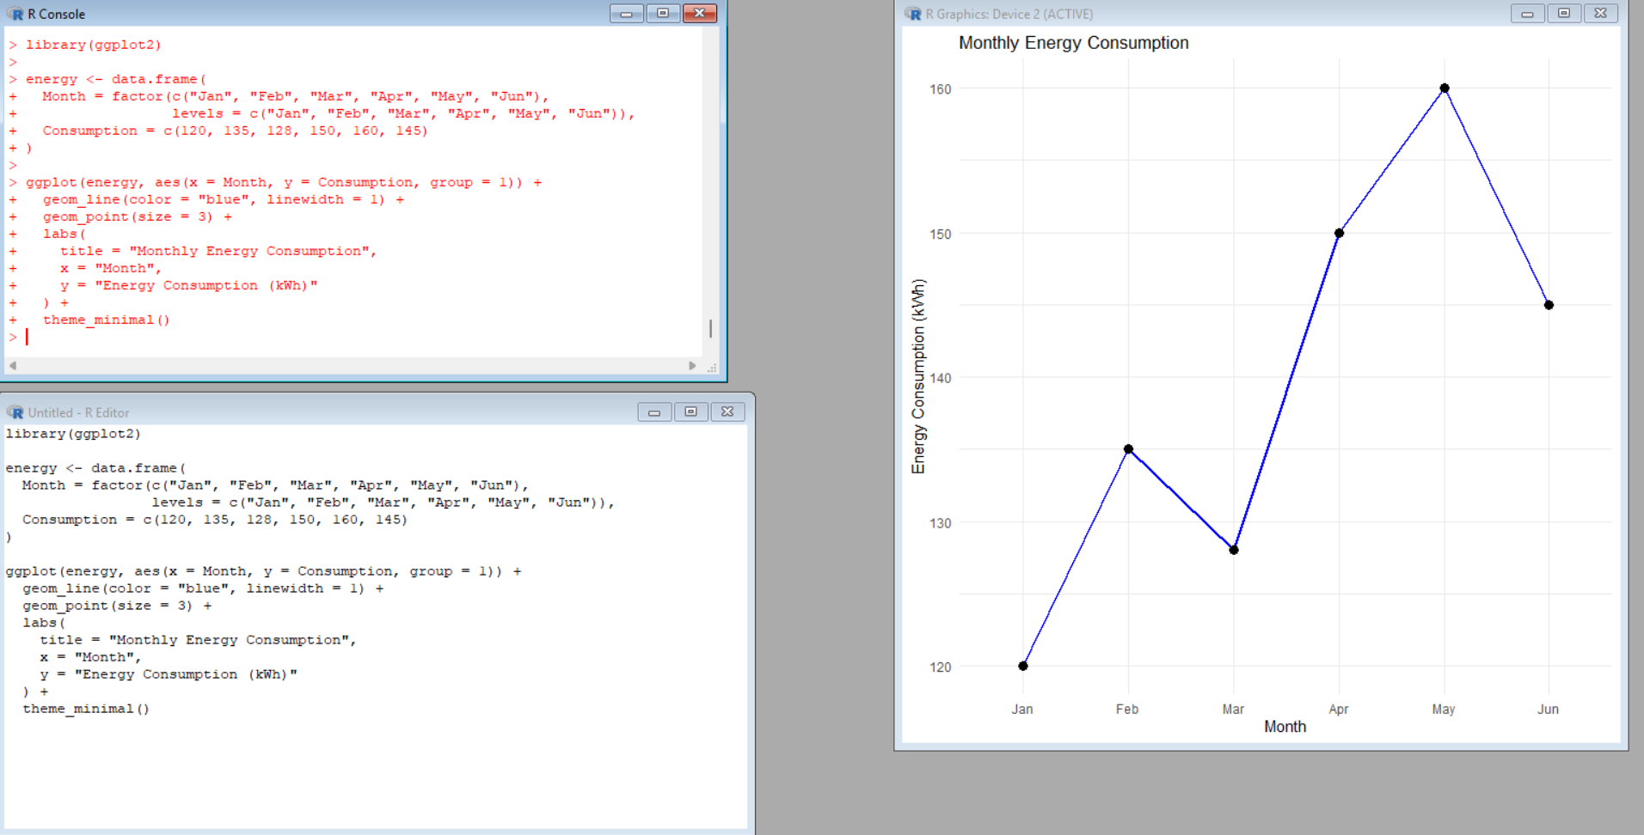
Output: The histogram displays the frequency distribution of energy consumption. The density plot shows the distribution pattern of the consumed energy values.
Q2. Bubble Scatter Plot: Temperature vs Energy Consumption
Program:
# Bubble scatter plot

energy <- read.csv("energy_consumption.csv")

symbols(
energy$Temperature,
energy$Units_Consumed,
circles = energy$Peak_Hours / 5,
inches = 0.3,
bg = rgb(0, 0, 1, alpha = 0.4),
fg = "blue",
xlab = "Temperature",
ylab = "Units Consumed",
main = "Temperature vs Energy Consumption"
)

text(
energy$Temperature,
energy$Units_Consumed,
labels = energy$Sector,
pos = 3,
cex = 0.7
)
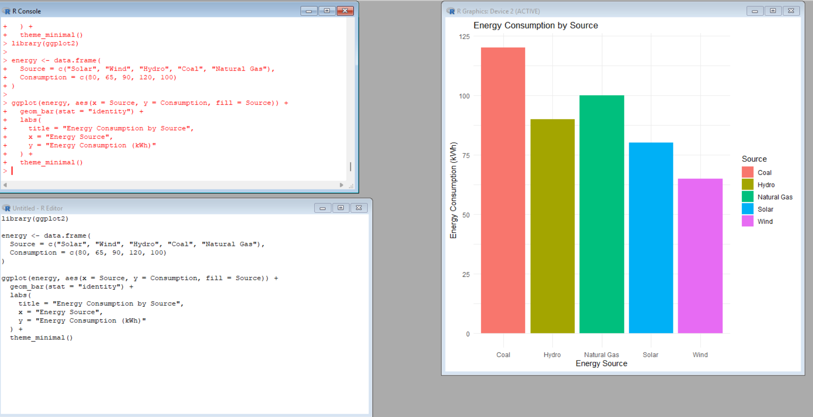
Output: The bubble scatter plot represents the relationship between temperature and energy consumption. Bubble size represents peak hours, while transparency helps distinguish overlapping bubbles.
Q3. Sector-Wise Renewable Energy Usage
Program:
# Average renewable energy usage by sector

energy <- read.csv("energy_consumption.csv")

sector_avg <- aggregate(
Renewable_Usage ~ Sector,
data = energy,
FUN = mean
)

print(sector_avg)

# Bar chart
barplot(
sector_avg$Renewable_Usage,
names.arg = sector_avg$Sector,
main = "Average Renewable Energy Usage by Sector",
xlab = "Sector",
ylab = "Average Renewable Usage",
col = c("lightgreen", "skyblue", "orange"),
border = "black"
)
Expected output table:
Sector | Average Renewable Usage
Commercial | 19
Industrial | 13.5
Residential | 23.5
Output: The table and bar chart compare average renewable energy usage across the three sectors.
Dataset CSV File
Save the following content as energy_consumption.csv in the same folder as your R program.
Sector,Region,Month,Temperature,Units_Consumed,Cost,Renewable_Usage,Peak_Hours
Residential,North,Jan,15,320,2100,22,4
Commercial,South,Jan,24,540,3600,18,6
Industrial,West,Feb,20,880,5900,12,8
Residential,East,Feb,18,350,2300,25,5
Commercial,North,Mar,28,610,4100,20,7
Industrial,South,Mar,30,920,6200,15,9
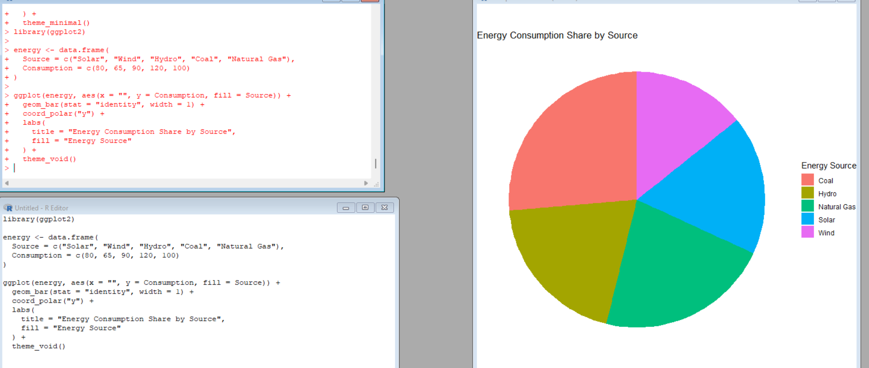
Q4. Tableau Dashboard Creation
Procedure:
- Open Tableau Desktop or Tableau Public.
- Connect to the energy_consumption.csv file.
- Verify that the fields are assigned the correct data types.
- Create a worksheet named Monthly Energy Consumption Trend.
  - Drag Month to Columns.
  - Drag Units_Consumed to Rows and select SUM.
  - Arrange the months in chronological order: Jan, Feb, Mar.
  - Select a line chart.
- Create a worksheet named Sector vs Region Heatmap.
  - Drag Sector to Rows.
  - Drag Region to Columns.
  - Drag Units_Consumed to Color.
  - Select the highlight table or heatmap chart type.
- Create a worksheet named Renewable Usage by Sector.
  - Drag Sector to Columns.
  - Drag Renewable_Usage to Rows.
  - Select Average as the aggregation.
  - Choose a bar chart.
- Create a new dashboard and add all three worksheets.
- Add filters for Month and Sector.
- Apply the filters to the relevant worksheets.
- Save the workbook and verify that the dashboard responds to filter selections.
Expected output: An interactive dashboard showing monthly energy consumption trends, sector-region consumption patterns, and renewable energy usage by sector.
5. OUTPUT
The following outputs are obtained after executing the R programs and creating the Tableau dashboard:
- Histogram showing the frequency distribution of units consumed.
- Density plot showing the distribution of energy consumption.
- Bubble scatter plot showing the relationship between temperature and energy consumption.
- Sector-wise renewable energy usage table.
- Bar chart comparing average renewable energy usage.
- Tableau dashboard containing the monthly trend, heatmap, and interactive filters.
6. INTERPRETATION
- Industrial consumption is higher than residential and commercial consumption in the given dataset.
- The highest recorded energy consumption is 920 units, observed in the Industrial sector in March.
- The lowest recorded energy consumption is 320 units, observed in the Residential sector in January.
- The highest energy cost is 6200, corresponding to the Industrial sector in March.
- The Residential sector has the highest average renewable usage value of 23.5.
- The Industrial sector has the lowest average renewable usage value of 13.5.
- The bubble scatter plot helps examine the relationship between temperature and energy consumption.
- The Tableau dashboard enables users to compare energy consumption across months, sectors, and regions.
These interpretations apply to the six observations provided and should not be treated as conclusions about all energy consumers.
7. RESULT
Thus, the energy consumption dataset was analyzed using R programming and Tableau. Histograms, density plots, bubble scatter plots, summary tables, and bar charts were used to study energy consumption and renewable energy usage. An interactive Tableau dashboard was designed to compare consumption patterns across months, sectors, and regions.

